Submitted by

Mohamed Khaled Galloul, SEC:2, B.N.:14

Submitted TO

ENG. Christeen Ramsis

|  |  |
| --- | --- |
| Task 1 – MNIST Report |  |

Examples:

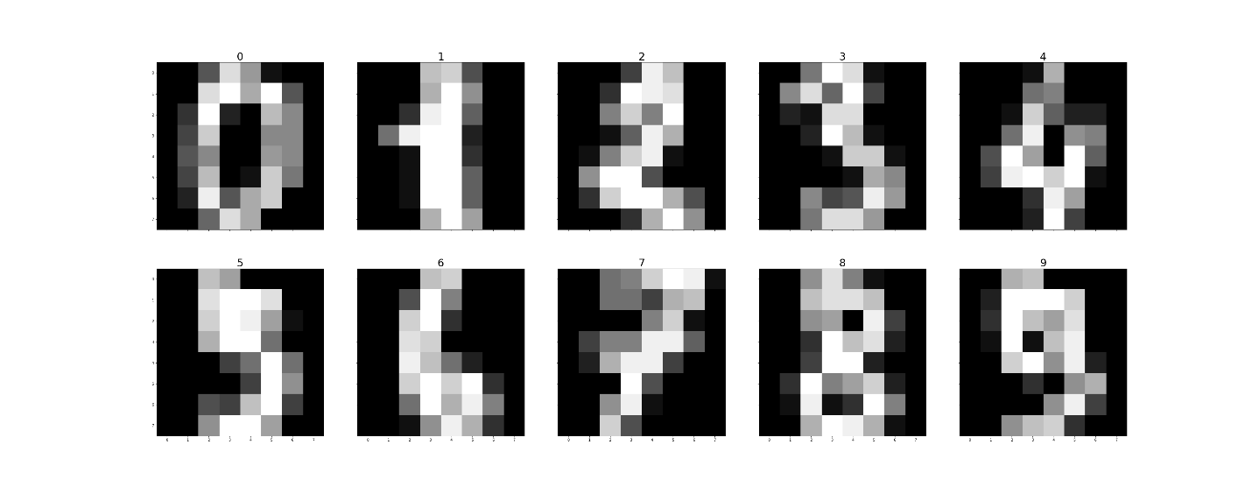

Figure : Samples from the dataset

Results:

1. Binary Classifier:

To classify digit either ‘zero’ or ‘not zero’

* 1. 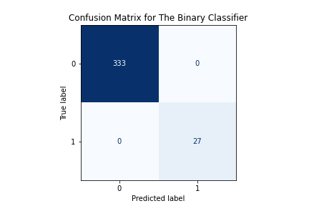Confusion Matrix

Figure : Confusion Matrix for the Binary Classifier

We can clearly see that the Binary classifier classified the two class correctly (Both the true positives and true negatives) with no false positives or false negatives.

* 1. Accuracy, Precision, Recall



Figure : Some Metrics for the Binary Classifier

Before we interprete our results here we shall remind ourselves with the definition of accuracy, precision, and recall.

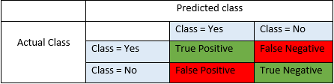

Figure : Confusion Matrix

**Accuracy** - Accuracy is the most intuitive performance measure and it is simply a ratio of correctly predicted observation to the total observations.

In other words,

Accuracy = (TP+TN) / (TP+FP+FN+TN)

**Precision** - Precision is the ratio of correctly predicted positive observations to the total predicted positive observations.

Precision = TP/(TP+FP)

**Recall**(Sensitivity) - Recall is the ratio of correctly predicted positive observations to the all observations in actual class

Recall = TP/(TP+FN)

So our binary classifier achieved 100% in all of the above metrices.

1. Multi-class Classifier:

To classify each digit in the MNIST dataset from ‘0’ to ‘9’ .

* 1. Confusion Matrix

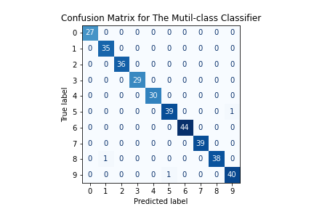

Figure : Confusion Matrix for the Multi-class Classifier

The classifier did well in classifying all classes except for class ‘5’, ‘8’ and ‘9’ where it misclassified a single image for each of these three classes.

* 1. Accuracy, Precision, Recall



Figure : Some Metrics for the Multi-class Classifier

We can see that the classifier did well in most cases but it misclassified 3 from all the 360 images in the test set which is not bad at all resulting in 99.17% in all the three metrics mentioned above, with some hyperparameter tuning we can get 100%.